**PROBLEM 1.-**

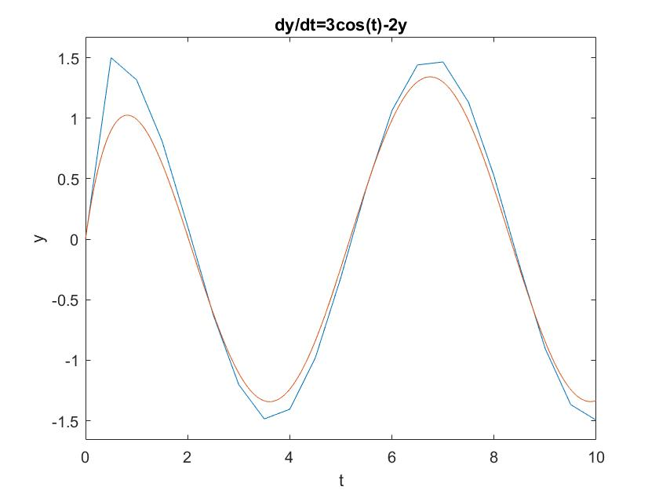clc, clear, close all

y0=0;

h=(**0.5,0.25,0.1**);

i=0.001;

t = 0:h:10;

x=0:i:10;

ya=zeros(size(t));

ya(1)=y0

yexact=-1.2*exp(-2*x)+0.6*sin(x)+1.2*cos(x)

for i=1:(length(t)-1)

k1 = -2*ya(i)+3*cos(t(i))

ya(i+1) = ya(i) + k1*h;

end

plot(t,ya,x,yexact);

xlabel('t'),ylabel('y')

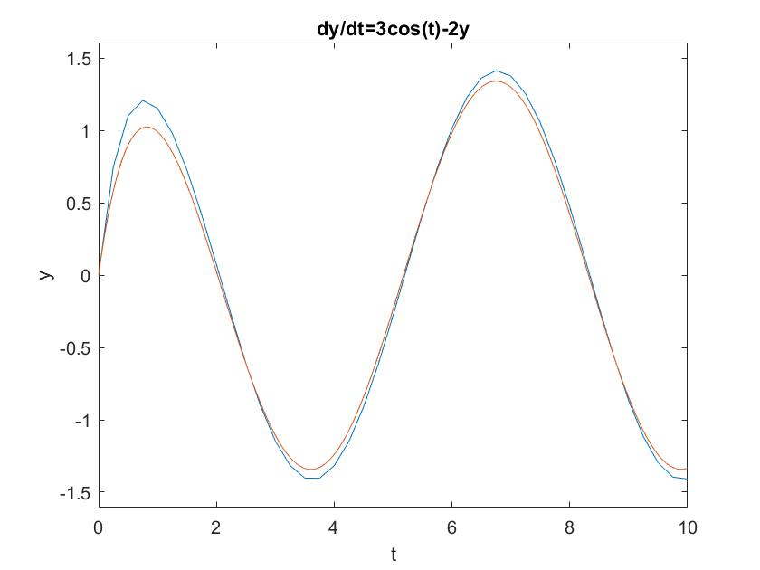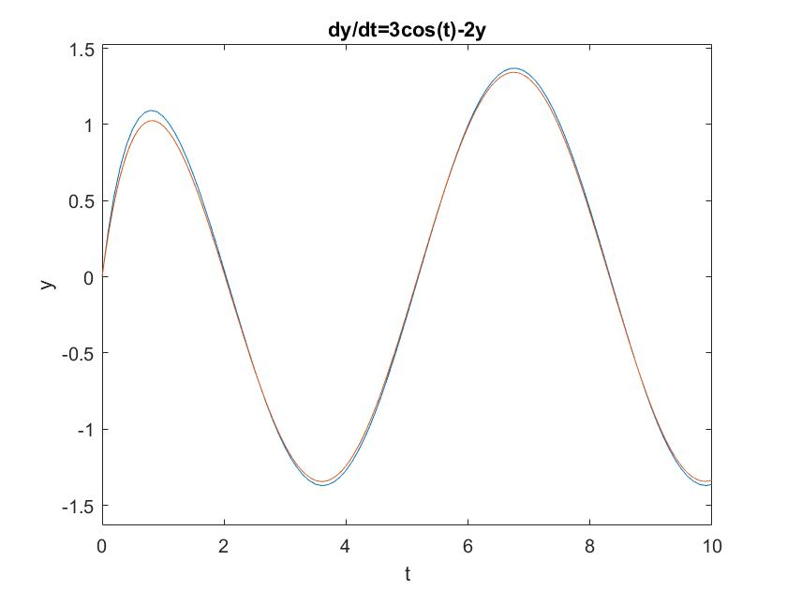title('dy/dt=3cos(t)-2y')

**PROBLEM 2.-**

clc, clear, close all;

a=0;

b=3;

N=100;

t=linspace(a,b,N)

dt=t(2)-t(1)

for IC = [-2:0.05:3]

y(1)=IC;

for i = 1:N-1

y(i+1) = dt*((-y(i))^3+2*(y(i))^2)+y(i);

end

plot(t,y), hold on

xlabel('t'),ylabel('y')

